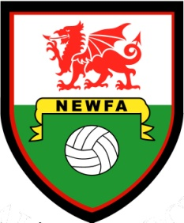
North East Wales Football Association
Cymdeithas Pel Droed Gogledd Dwyrain Cymru
CAUTION REPORT FORM FOR REFEREES
Teams |  | v
Venue |  | Match Date
Competition
Please detail all cautions from the above match and the relevant Caution Code for each player– see below
Player | Club | Caution Code | NEWFA use only

A player, substitute or substituted player shall be cautioned and shown the Yellow Card if he/she:

C1 - is guilty of unsporting behaviour (this may include:  Foul Tackle, Dangerous or Foul Play, Shirt Pulling, Tripping, Obstruction, Hand Ball, Simulation or any other offence deemed by the Referee to be unsporting behaviour.) |  | C5 - fails to respect the required distance when play is restarted with a Corner Kick or Free Kick or throw in.
C2 - shows dissent by word or action.  C3 - persistently infringes the Laws of the Game. |  | C6 - enters or re-enters the Field of Play without the Referee’s permission.
C4 - delays the restart of play. |  | C7 - deliberately leaves the Field of Play without the Referee’s permission.
Referee’s Name: | Signed: |  | Date:

Return to NEWFA Disciplinary Secretary:
Mr Brian Johnson, Disciplinary Secretary, 22 Ffordd Mabon, Llay, Wrexham, LL12 0RS
Completed forms to be returned within two days (excluding Sundays).
Forms can be completed online - newfa.co.uk

Alternatively: Completed and signed report forms can be scanned and e-mailed to disciplinenewfa@gmail.com please state “Caution Report Form” in subject line of your e-mail.

Replacement forms can be downloaded from www.newfa.co.uk

