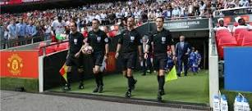

Do you fancy becoming a referee??
Are you aged 14 years or older??
Do you want to earn more pocket money that doing a paper round every morning??
In the local junior leagues, you can get paid from £18 a game on a Saturday morning. For the adults’ game fees start at £25 obviously going higher the higher the league you officiate in.
The course as is stands is an online course and costs £70, this includes the online course, a full matchday referee’s kit with accessories, ie, flags, whistle, note book and cards.
As well as having all the above, you will have the full support from NEWFA and me in particular.
If you’re interested in becoming a referee please visit
www.becomearef.wales

Under the current climate with no football being played you may find it’s the ideal opportunity to take the referee’s course as it’s online, so you don’t have contact with real people.

STEVE JONES
REFEREE’S OFFICER
NEWFA
Email: ronewfa@gmail.com – phone 07723051754

